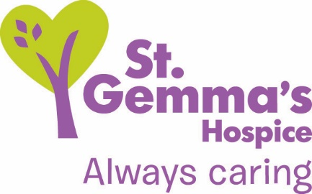

Registered Charity No. 1015941

Title of Role: Volunteer Ambassador
Department: Fundraising
Supervisor: Senior Fundraiser (Community)
Location: Various locations in Leeds and surrounding areas
Time commitment: Dependent on availability
DBS check needed? No

St Gemma’s Hospice provides the best possible care and quality of life for local people with cancer and other life threatening illnesses. It’s a friendly, warm and safe place at the heart of the local community with a large range of expert services to support patients, their families and friends. Whether our volunteers help in our shops or at the Hospice, they all contribute to helping St Gemma’s care for local people at the most difficult time in their lives.

Role Summary
St Gemma’s Hospice relies on the support of the local community through their fundraising and awareness raising efforts. With the help of our Ambassadors we are able to reach more groups, attend more fundraising events and have greater representation in the communities of Leeds. The Ambassador role is for people who are dedicated to the work of St Gemma’s Hospice. The role is varied and flexible depending on your own experience, commitments and skills. Main duties may include attending events on the Hospice’s behalf, speaking to groups about our work and supporting the Fundraising Department in various ways.

- What’s involved?

The role of an Ambassador is varied and the following duties will depend on your own preferences, skills and experience:
- To attend community fundraising events on behalf of St Gemma’s Hospice fundraising team. This may include speaking about our work, attending cheque presentations, running information and fundraising stalls or representing the Hospice.
- To help at St Gemma’s Hospice organised events throughout the year when possible. This includes our Hospice fairs, sponsored events and various others at the Hospice and in the local community.
- To help promote all Hospice events and initiatives to the local community.
- To become familiar with the Hospices key messages to ensure you are able to answer questions from members of the public or refer them to other information sources (such as the website or relevant staff member).

- What we will offer you
- The opportunity to represent your local Hospice in the local community.
- The opportunity to receive training to help you deliver presentations on behalf of St Gemma’s
- The chance to learn about fundraising
- The prospect of improving your presentation and communication skills.
- The chance to use your skills and experience to support the Hospice’s fundraising activities.
- The opportunity to work with a friendly team
- A named line manager who will support you in your work
- An invitation to a Hospice wide induction
- Invitations to Volunteer thank you events and Quarterly Ambassadors meetings.

- What we’d like from you
- To have passion and enthusiasm for the work of St Gemma’s Hospice
- To be polite and friendly
- To be committed to advocating the Hospice in the local community
- To follow all relevant procedures and policies including Cash Handling and Confidentiality.
- To have good organisational skills and to be able to work independently
- To have some experience or awareness of the work that St Gemma’s Hospice does.

To discuss this opportunity in greater detail please call Anna Jones on 0113 218 5559, or email annaj@st-gemma.co.uk.

Values and Behaviours

St Gemma’s Hospice has a set of values and behaviours and all volunteers are expected to behave in line with the values detailed below.

- Caring - Treating each person with kindness, empathy, compassion and respect.
- Aspiring - Continually learning and developing; striving for excellence in everything we do.
- Professional - Delivering high standards through team work, a skilled workforce and good governance.

Thank you

St Gemma’s Hospice could not survive without the help and support provided by volunteers who give their time and energy so selflessly. Your contribution really will make a difference to the lives of local people.

September 2019

