Employee Specification – Ward Secretary (Bank) | 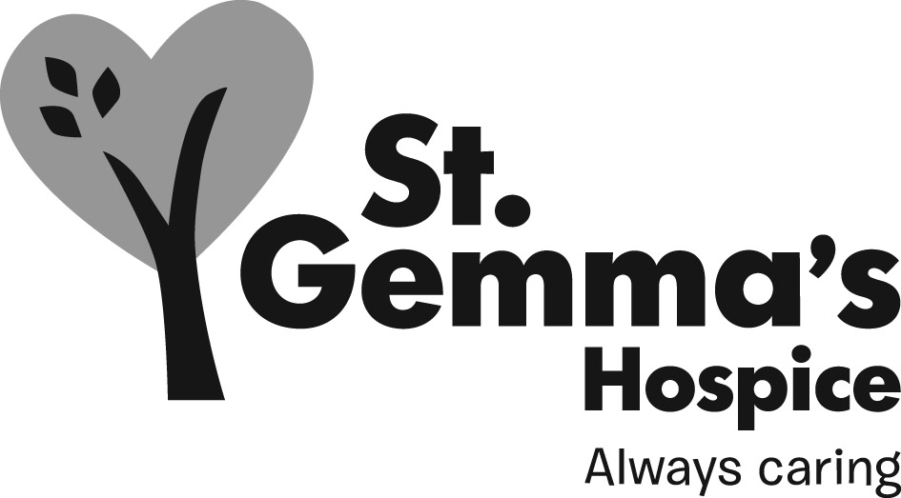

St Gemma’s is an equal opportunities employer and promotes the equality of access to employment. St Gemma’s Bank Secretaries are required to follow the specific Personnel policies supporting recruitment & selection.

Attributes | Essential | Desirable | How identified  Interview = I  Application form = A
Experience
Secretarial experience |  |  | I & A
Medical secretarial experience |  |  | I & A
Audio typing |  |  | I & A
Databases |  |  | I & A
Minute taking |  |  | I & A
Knowledge
In-depth knowledge to an intermediate level of Microsoft Outlook/Word |  |  | I & A
Basic knowledge of Excel/PowerPoint |  |  | I & A
Qualifications/Training
Evidence of having undertaken formal IT training |  |  | I & A
RSA/OCR Level 2 in Typing & Word-processing or equivalent |  |  | A & Certificates
RSA/OCR Level 3 in Typing & Word-processing or equivalent |  |  | A & Certificates
Skills/Abilities
Good prioritising, admin and organising skills |  |  | I & A
Good written and verbal communication skills |  |  | I & A
Excellent telephone manner |  |  | I & A
Ability to use own initiative |  |  | I
Ability to work as part of a team |  |  | I
Ability to work with minimal supervision |  |  | I
Personal Attributes
Good interpersonal skills |  |  | I
Flexible |  |  | I

