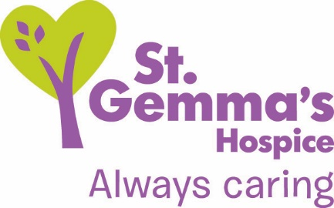

Registered Charity No. 1015941

Title of Role: Day Services Driver Volunteer
Department: Day Services
Supervisor: Therapy and Day Services Manager
Location: St Gemma’s Hospice, 329 Harrogate Road, Leeds, LS17 6QD
Time commitment: Minimum once a week on any day Monday - Friday
Deadline for applications: 9am Monday 28th January
DBS check needed? Yes
If yes: This post is exempt from the Rehabilitation of Offenders Act 1974 and therefore a Disclosure and Barring Services (DBS) check will be carried out on preferred candidates. Please see statement on recruitment of ex-offenders by visiting www.st-gemma.co.uk/volunteering.

St Gemma’s Hospice provides the best possible care and quality of life for local people with cancer and other life threatening illnesses. It’s a friendly, warm and safe place at the heart of the local community with a large range of expert services to support patients, their families and friends.

Role Summary
St Gemma’s Hospice Day Services provide extra support to patients and their families if the patient chooses to remain at home during their illness. Service users can enjoy the friendly and therapeutic environment, access creative therapy activities, Complementary Therapy, emotional support, appointments with specialist doctors and therapists. This role involves using your own vehicle to transport more independently mobile patients between their homes and the Hospice so that they can access these vital services. You will not be required to transport patients who need significant mobility assistance.

- What’s involved?
- Transporting more independently mobile service users safely between their homes and the Hospice as requested.
- You will not be required to transport patients who need significant mobility assistance.
- Liaising with the Day Services Secretary about the timing, name, relevant details and address of a service user requiring transport.
- Speaking to the service user about expected pick up (and if relevant) drop off times.
- Feeding back verbally or in written form to nursing staff about any issues arising from or with the service user.
- Talking to patients about the various activities that may be on offer within Day Services.
- Moving wheelchairs only with SHAM (Safe Handling and Moving) training and when requested to do so by staff.
- Assessing if the service user is safe to travel on each visit and contacting the Day Services Registered Nurse if there is any change in their mobility or health.
- Maintaining confidentiality at all times in matters relating to patients, their families and the Hospice.
- Operating within all relevant policies and guidelines including health and safety, confidentiality, diversity, safe moving and handling and lone working.

- What we will offer you
- Full induction and training to acquire the skills necessary.
- A named supervisor who will support you in your work.
- Opportunity to gain experience working in a caring profession.
- References and the development of a portfolio of skills and training.
- Travel expenses and an enhanced Disclosure and Barring Service check.
- Invitations to Volunteer thank you events.

- What we’d like from you
- Caring person who is committed to help improve patient quality of life.
- Be able to work in a professional manner with patients who have a terminal illness.
- Experience of working in a caring profession is useful but not essential.
- Use of a vehicle; ideally the vehicle would have 5 doors and not be too low for gaining access.
- A current driving licence.
- To be a mobile phone user.
- Commitment of attendance and of informing the Day Services Team of any holiday or illness.

- How to apply
Please submit an application form online by visiting www.st-gemma.co.uk/volunteering.

To discuss this opportunity in greater detail please call Shona Eyre on 0113 218 5294 or email shona.eyre@st-gemma.co.uk

Thank you

St Gemma’s Hospice could not survive without the help and support provided by volunteers who give their time and energy so selflessly. Your contribution really will make a difference to the lives of local people.

January 2019

