Employee Specification –  Housekeeper / Laundry Assistant (Bank) | 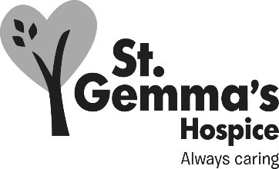

St Gemma’s is an equal opportunities employer and promotes the equality of access for all. St Gemma’s Bank Housekeeper/Laundry Assistants are required to follow the specific personnel policies supporting recruitment and selection.

ATTRIBUTES | ESSENTIAL | DESIRABLE | HOW IDENTIFIED
EXPERIENCE  Customer services  Working within a caring environment  Housekeeping  Laundry | √  √ | √  √ | Application form/Interview  Application form/Interview  Application form/Interview  Application form/Interview
KNOWLEDGE  COSHH  Infection control | √ | √ | Application form/Interview  Application form/Interview

ATTRIBUTES | ESSENTIAL | DESIRABLE | HOW IDENTIFIED
QUALIFICATIONS/TRAINING  NVQ Level 1 Housekeeping  NVQ Level 1 Laundry |  | √  √ | Application form  Application form
SKILLS/ABILITIES  Organisational  Good interpersonal  Good written and verbal communication  To work within a team  To work with minimal supervision | √  √  √  √  √ |  | Application form/Interview  Application form/Interview  Application form/Interview  Application form/Interview  Application form/Interview
PERSONAL ATTRIBUTES  Flexibility with hours  Reliable  Smart appearance | √  √  √ |  | Interview  Application form/Interview  Interview

July 2021

