Employee Specification  Community Services Administrator | 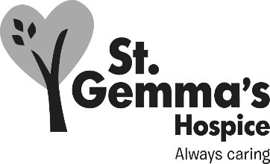

St Gemma’s Hospice is an equal opportunities employer and endeavours to recruit the best person for each vacancy regardless of gender, race, religion or belief, age, sexual orientation, disability or any other factor irrelevant to the ability to do the job. Employees are required to follow the Personnel policies and procedures supporting recruitment and selection.

Attributes | Essential | Desirable | How identified  Interview = I  Application form = A
Experience
Administrative experience including maintaining office systems |  |  | A/I
Supporting a team of staff in a fast-paced environment |  |  | A/I
Supporting clients/patients by dealing with phone calls effectively and sensitively |  |  | A/I
Inputting and retrieving information from SystmOne and PPM/PPM+/LCR or similar database |  |  | A/I
Knowledge
Understanding of confidentiality requirements, including GDPR principles |  |  | A/I
In-depth knowledge to an intermediate level of Microsoft Office: Outlook, Word, PowerPoint and Excel |  |  | A/I
Knowledge and use of databases (e.g. SystmOne, HR Systems, Access) |  |  | A/I
Qualifications/Training
GCSE at grade C or above or equivalent in English and Maths |  |  | A
Evidence of formal IT training |  |  | A/I

Attributes | Essential | Desirable | How identified  Interview = I  Application form = A
Skills/Abilities
Strong organisational skills; ability to move between different tasks easily in a busy environment |  |  | A/I
Ability to use own initiative and work proactively, both independently and as part of a team (working independently at weekends) |  |  | A/I
Strong interpersonal skills, ability to empathise with and support distressed patients and bereaved family members |  |  | I
Good written and verbal communication skills |  |  | A/I
Ability to work well at all levels, internally and externally |  |  | A/I
Personal Attributes
Commitment to high quality patient care and support services and to our Hospice values of caring, aspiring and professional |  |  | I
Flexible approach to work and clear understanding of the need to meet deadlines |  |  | I
Values diversity and difference, recognises the contributions of others |  |  | I

May 2021

