Employee Specification –Facilities Services Assistant (Casual) | 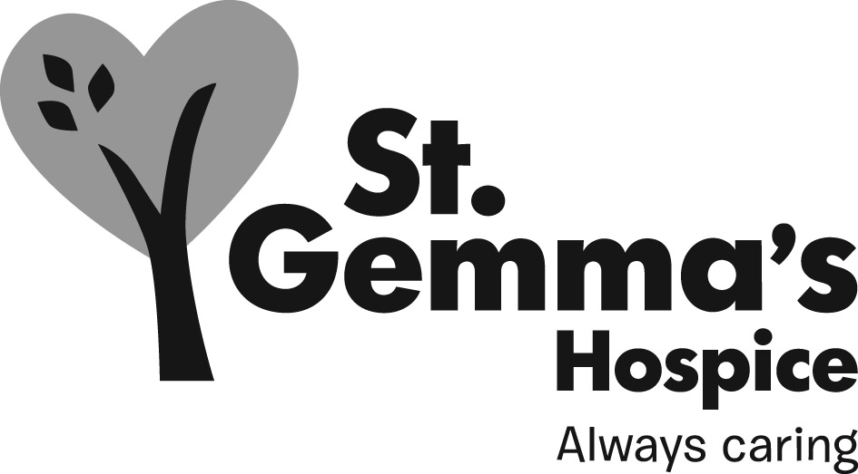

St Gemma’s is an equal opportunities employer and promotes the equality of access to employment. St Gemma’s Bank Bistro/Food Assistants are required to follow the specific Personnel policies supporting recruitment & selection.

Attributes | Essential | Desirable | How identified  Interview = I  Application form = A
Experience
Customer service experience |  |  | A / I
Housekeeping/ Cleaning experience in a catering and environment |  |  | A / I
Food service experience |  |  | A / I
Housekeeping |  |  | A / I
Laundry |  |  | A / I
Knowledge
Awareness of kitchen hygiene practices |  |  | A / I
Knowledge of providing an events and functions service |  |  | A / I
COSHH |  |  | A / I
Infection Control Practices |  |  | A / I
Qualifications/Training
Basic Food Hygiene Certificate |  |  | A
NVQ Level 2 Customer Services |  |  | A
QCF (NVQ) Level 1 Housekeeping |  |  | A/I
QCF (NVQ) Level 1 Laundry |  |  | A/I
Skills/Abilities
Good organisational skills |  |  | A / I
Good communication skills |  |  | I
Basic numeracy skills |  |  | I
Ability to work as part of a team |  |  | A / I
Ability to work with minimum supervision |  |  | A / I
Personal Attributes
Good interpersonal skills |  |  | A / I
Ability to work flexibly |  |  | I
Reliable |  |  | I
Smart appearance |  |  | I

