Employee Specification – Senior Fundraiser (Events) | 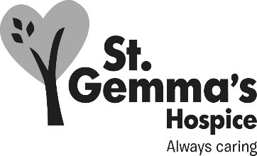

St Gemma’s Hospice is an equal opportunities employer and endeavours to recruit the best person for each vacancy regardless of gender, race, religion or belief, age, sexual orientation, disability or any other factor irrelevant to the ability to do the job. Employees are required to follow the Personnel policies and procedures supporting recruitment and selection.

Attributes | Essential | Desirable | How identified  Interview = I  Application form = A
Experience
Previous experience in fundraising |  |  | A / I
Organising events from creating to completion |  |  | A / I
Working with and knowledge of a database |  |  | A / I
Working towards and achieving financial and/or time related targets |  |  | A / I
Working with volunteers |  |  | A / I
Staff management |  |  | A / I
Knowledge
Leeds and surrounding area |  |  | I
Charity law in relation to fundraising |  |  | I
Qualifications/Training
Qualification or proof of training in fundraising |  |  | A / I
Ability to drive and use of a car |  |  | A / I
Skills/Abilities
Good IT skills including proficient use of Microsoft Office programmes |  |  | A / I
Good written/oral presentation skills |  |  | A / I
Well developed inter-personal skills |  |  | I
Ability to form good working relationships with managers, staff and volunteers at all levels |  |  | I
Excellent organisational and planning skills |  |  | A / I
Ability to prioritise own workload, perform under pressure and meet tight deadlines |  |  | A / I
Ability to manually handle event equipment |  |  | I
Personal Attributes
Self-motivated |  |  | I
Ability to work as a team member |  |  | I
Ability to be adaptable and work flexibly |  |  | I
A professional manner with both internal and external contacts |  |  | I

