Employee Specification – Staff Nurse – Community and Day Services | 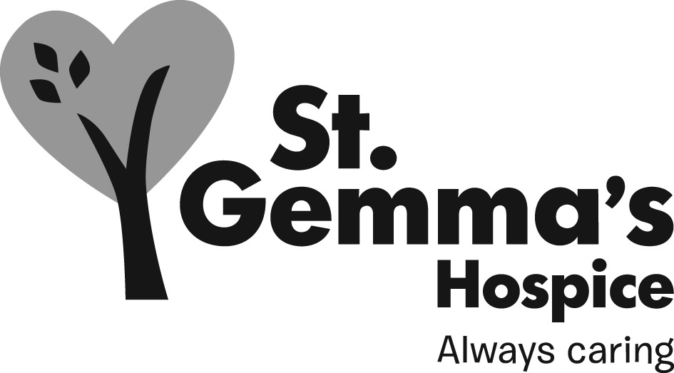

St Gemma’s Hospice is an equal opportunities employer and endeavours to recruit the best person for each vacancy regardless of gender, race, religion or belief, age, sexual orientation, disability or any other factor irrelevant to the ability to do the job. Employees are required to follow the Personnel policies and procedures supporting recruitment and selection.

Attributes | Essential | Desirable | How identified  Interview = I  Application form = A
Experience
Post registration experience in a variety of settings |  |  | A / I
Management experience |  |  | A/ I
Previous experience caring for patients with palliative care needs and/or long term conditions |  |  | A / I
Experience of working in a multi-disciplinary setting |  |  | A/ I
Community experience |  |  | A/ I
Mentorship experience |  |  | A/ I
Knowledge
Palliative and end of life care |  |  | I
Research/evidence based practice |  |  | I
Awareness of current issues in palliative care |  |  | I
Evidence of professional updating |  |  | I
Qualifications/Training
Registered Nurse |  |  | A
Certificate in Palliative Care/associated modules |  |  | A
Teaching/assessing qualification |  |  | A
Advanced communication skills training |  |  | A
Skills/Abilities
Time management & organisation skills |  |  | I
Presentation skills |  |  | I
Performance review skills |  |  | I
Good written and verbal communication skills |  |  | A / I
Ability to work within a team |  |  | I
Ability to deal with emotive situations |  |  | I
Basic IT skills – Word, email |  |  | A
Personal Attributes
Motivated |  |  | I
Interpersonal skills |  |  | I
Ability to be flexible when required |  |  | I
Committed to caring for patients with palliative care needs and their families |  |  | I

