Employee Specification – Graphic Designer | 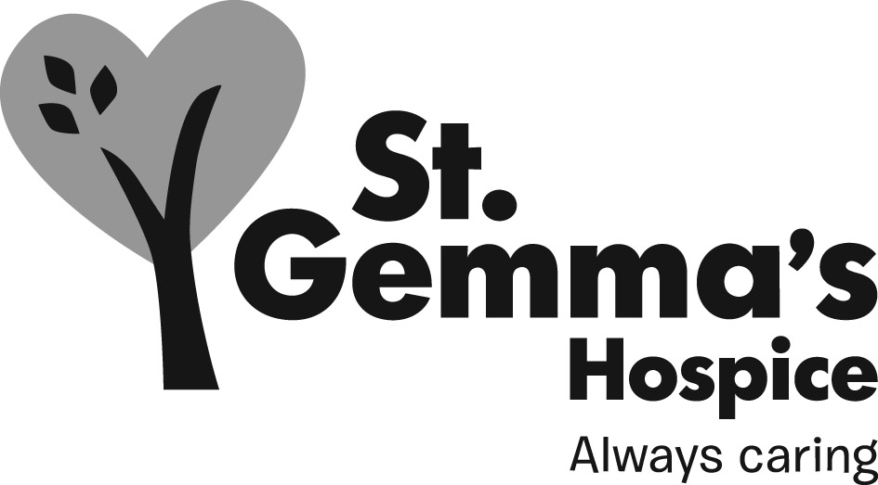

St Gemma’s Hospice is an equal opportunities employer and endeavours to recruit the best person for each vacancy regardless of gender, race, religion or belief, age, sexual orientation, disability or any other factor irrelevant to the ability to do the job. Employees are required to follow the Personnel policies and procedures supporting recruitment and selection.

ATTRIBUTES | ESSENTIAL | DESIRABLE | HOW IDENTIFIED  Application form = A  Interview = I
Experience
Excellent design skills in a work environment |  |  | A, I
Previous experience in marketing and communications |  |  | A, I
Ability to work with people at all levels, internally and externally |  |  | I
Ability to produce high quality information with specific audiences in mind |  |  | A, I
Prioritise demanding workloads and timescales on own initiative |  |  | A, I
Providing professional advice and support where needed |  |  | I
Knowledge
Competent use of graphic design packages such as InDesign, Illustrator etc |  |  | A, I
Knowledge of website management packages such as WordPress |  |  | A, I
Knowledge of working within brand guidelines and protecting brand image |  |  | I
Understanding print processes and making recommendations based on the item to be printed, finish required, budget available etc |  |  | I
Qualifications/Training
Formal graphic design qualification and/or training |  |  | A, I
Skills/Abilities
Able to work alone, on own initiative and without daily supervision |  |  | I
Strong verbal and written communications skills |  |  | A, I
Able to work to demanding deadlines, prioritising workload |  |  | A, I
Adaptable writing style |  |  | I
Looking at new trends and developments such as digital animation |  |  | A,I
High levels of computer literacy |  |  | A, I
Ability to work co-operatively with others |  |  | A, I
Good time management skills |  |  | A, I
Personal Attributes
Organised and self-motivated |  |  | A, I
Creative and flair for design |  |  | A, I
Approachable, amenable and co-operative |  |  | A, I

