Role Profile – Graphic Designer |  | 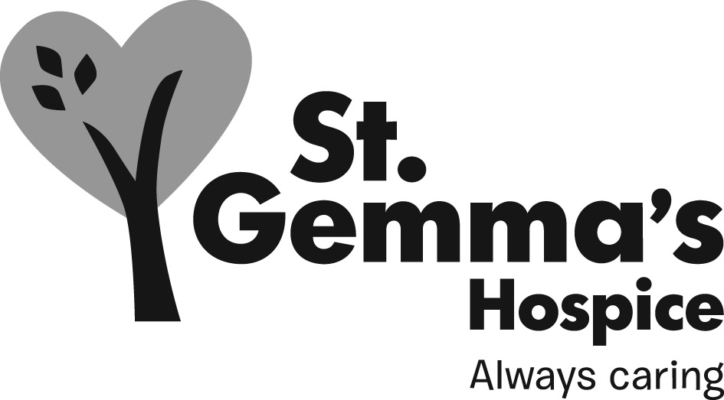
Reports to: | Head of Marketing and Communications
Accountable to: | Director of Income Generation

- Main Purpose of Post

1.1 To market and publicise St Gemma’s Hospice, to help build the profile, awareness and

understanding of St Gemma’s work with all key audiences across Leeds and beyond.

1.2 To provide a professional graphic design service to the Hospice ensuring that all materials are produced to the highest standards, within agreed timescales and budgets and in keeping with St Gemma's Hospice brand, image and values.

1.3 To work as part of the small Marketing and Communications team to assist in the delivery of the St Gemma's Hospice strategy, maximising communications and marketing opportunities internally and externally.

Marketing and Communications team structure – January 2022

2.0 Specific Duties and Responsibilities

2.1 Work across all departments and with staff at all levels to provide a quality design service for the Hospice.

2.2 Design eye-catching and audience-specific publications including Newsletters,
internal Bulletins (monthly), leaflets, posters and flyers for both clinical and non-clinical
departments (ongoing).

2.3 Ensure that all materials are designed in line with the Hospice’s brand guidelines.
2.4 Co-ordinate an efficient system, in conjunction with the Head of Marketing and Communications (HoMC), to ensure all design requests are appropriately prioritised and delivered on time.
2.5 Ensure all materials are designed using appropriate design packages and are print-ready when necessary.
2.6 Liaise with internal colleagues and external printers to discuss print requirements and specifications. Advise colleagues on most cost effective designs and means of printing.
2.7 Liaise with wider Hospice staff and volunteers, patients and families as necessary to gather news stories or other content, managing relationships in an appropriate manner.

2.8 Help ensure promotional materials and online information is up to date and consistent with
the Hospice’s messages and brand values.

2.9 Work with the Digital Marketing and Communications Managers to develop and maintain an
effective online photo library of images and relevant consent/permission forms.

2.10 Work with the Head of Marketing and Communications and the Digital Marketing and Communications Managers to ensure the Hospice’s brand is consistently applied and used, offering advice to staff and others regarding the correct application of the logo and branding and ensuring brand standards are upheld at all times.
3.0 Values and Behaviours
St Gemma’s has a set of values and behaviours to improve the experience for our patients and our staff. This means that in undertaking this role the post holder is expected at all times to behave in a way that demonstrates commitment to the delivery of thoughtful care to all and continual improvement in line with the values detailed below.
Caring – Treating each person with kindness, empathy, compassion and respect.
Aspiring – continually learning and developing; striving for excellence in everything we do
Professional – Delivering high standards through team work, a skilled workforce and good governance
4.0 General duties and responsibilities

4.1 All St Gemma’s employees are required to abide by the Health and Safety at Work Act, complete annual mandatory training sessions and ensure that they comply with Hospice policies and procedures at all times.

4.2 Employees must demonstrate commitment to their own personal development and are required to make a positive contribution to fundraising and raising the profile of the Hospice locally and nationally.

4.3 Strict confidentiality applying to all aspects of Hospice business must be observed at all times.

This Role Profile is not exhaustive. It will be subject to periodic review and may be amended following discussion between the postholder and employer.

