Employee Specification – Hospitality Assistant | 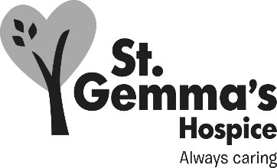
St Gemma’s Hospice is an equal opportunities employer and endeavours to recruit the best person for each vacancy regardless of gender, race, religion or belief, age, sexual orientation, disability or any other factor irrelevant to the ability to do the job. Employees are required to follow the Personnel policies and procedures supporting recruitment and selection.
Attributes | Essential | Desirable | How identified  Interview = I  Application form = A
Experience
Cleaning experience in a catering environment |  |  | A / I
Food service experience |  |  | A / I
Knowledge
Awareness of kitchen hygiene practices |  |  | A / I
Qualifications/Training
Basic Food Hygiene Certificate |  |  | A
NVQ Level 2 Customer Services |  |  | A
Skills/Abilities
Good organisational skills |  |  | A / I
Good communication skills |  |  | I
Basic numeracy skills |  |  | I
Ability to work as part of a team |  |  | A / I
Ability to work with minimum supervision |  |  | A / I
Personal Attributes
Ability to work flexibly |  |  | A / I
Reliable |  |  | I

