Employee Specification – Housekeeper / Laundry Assistant | 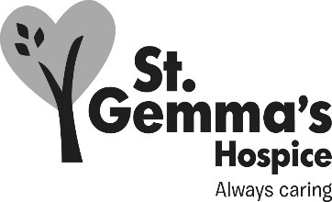

St Gemma’s Hospice is an equal opportunities employer and endeavours to recruit the best person for each vacancy regardless of gender, race, religion or belief, age, sexual orientation, disability or any other factor irrelevant to the ability to do the job. Employees are required to follow the Personnel policies and procedures supporting recruitment and selection.

Attributes | Essential | Desirable | How identified  Interview = I  Application form = A
Experience
Customer services |  |  | A / I
Working within a caring environment |  |  | A / I
Housekeeping |  |  | A / I
Laundry |  |  | A / I
Knowledge
COSHH |  |  | A / I
Infection Control |  |  | A / I
Qualifications/Training
QCF (NVQ) Level 1 Housekeeping |  |  | A
QCF (NVQ) Level 1 Laundry |  |  | A
Skills/Abilities
Organisational |  |  | A / I
Good interpersonal |  |  | A / I
Good written and verbal communication |  |  | A / I
To work within a team |  |  | A / I
To work with minimal supervision |  |  | A / I
Personal Attributes
Flexibility with hours |  |  | I
Reliable |  |  | A / I
Smart appearance |  |  | I

