Employee Specification - IPU Ward Sister/Charge Nurse | 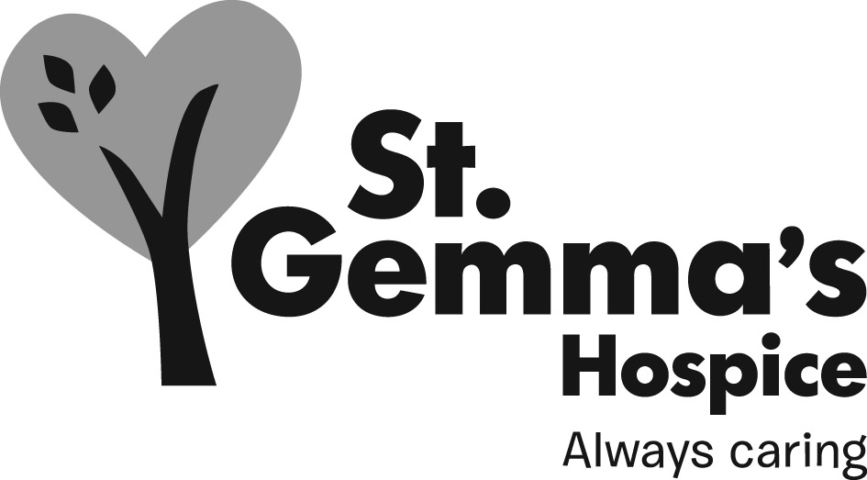

St Gemma’s Hospice is an equal opportunities employer and endeavors to recruit the best person for each vacancy regardless of gender, race, religion or belief, age, sexual orientation, disability or any other factor irrelevant to the ability to do the job. Employees are required to follow the Personnel policies and procedures supporting recruitment and selection.

Attributes | Essential | Desirable | How identified  Interview = I  Application form = A
Experience
Demonstrable experience in palliative/end of life care | Y |  | I/A
Managing a ward/clinical environment |  | Y | I/A
Experience of line management/supervision | Y |  | I/A
Proven ability to lead and deliver change | Y |  | I/A
Teaching to a range of professionals | Y |  | I/A
Implementing and using clinical governance systems, eg clinical effectiveness, risk management, performance management. |  | Y | I/A
Involvement in research |  | Y | I/A
Writing for publication |  | Y | I/A
Knowledge
Expert knowledge of clinical practice in specialist palliative care |  | Y | I/A
National developments in palliative/end of life care |  | Y | I/A
Standards of professional practice | Y |  | I/A
Change management and service evaluation and improvement techniques |  | Y | I/A
Ability to critically appraise information sources relevant to the area of practice and role | Y |  | I
Qualifications/Training
First Level Registered Nurse – current registration with NMC | Y |  | A
Health related degree (or willing to work towards) | Y |  | A
20 CAT points in specialist palliative care (or willing to work towards) | Y |  | A
Evidence of Masters level study |  | Y | A
Non-Medical Prescriber (or willing to work towards) |  | Y | I/A
Advanced assessment skills (or willing to work towards) |  | Y | I/A
Advanced communication skills | Y |  | A
Teaching and assessing qualification | Y |  | A
Leadership/management training |  | Y | A
Evidence of continuing professional development | Y |  | A
Skills/Abilities
Expert clinical skills | Y |  | I
Ability to lead and be a part of a team | Y |  | I
Ability to communicate effectively at all levels | Y |  | I
Ability to adapt to changing situations and environments | Y |  | I
Good standard of IT literacy | Y |  | I/A
Ability to organise and prioritise workload | Y |  | I
Personal Attributes
A strong commitment to the ethos and values of St Gemma’s Hospice and to the delivery of excellence in all aspects of care provision | Y |  | I
A strong commitment to equality in service provision recognizing the diversity in Leeds | Y |  | I
Communication skills and interpersonal style that engage, motivate, inspire and enthuse staff and volunteers. | Y |  | I
Credible clinical leader | Y |  | I
Innovative thinker | Y |  | I

