Employee Specification – Major Donor Manager | 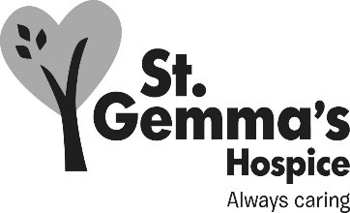

St Gemma’s Hospice is an equal opportunities employer and endeavours to recruit the best person for each vacancy regardless of gender, race, religion or belief, age, sexual orientation, disability or any other factor irrelevant to the ability to do the job. Employees are required to follow the Personnel policies and procedures supporting recruitment and selection.

Attributes | Essential | Desirable | How identified  Interview = I  Application form = A
Experience
Fundraising Qualification |  |  | A / I
Experience in Major Donor / Major Gifts fundraising |  |  | A / I
Experience in Executive level Business Development or sales |  |  | A / I
Experience of producing major donor / gifts fundraising plans |  |  | A / I
Experience of building sustainable business relationships |  |  | A / I
Knowledge
Knowledge of fundraising or sales based income generation |  |  | A / I
Knowledge of CRM systems |  |  | A / I
Knowledge of marketing techniques |  |  | A / I
Skills/Abilities
Ability to form good working relationships with internal and external parties |  |  | I
Good people skills and effective leadership skills |  |  | I
Ability to prioritise own workload and that of others |  |  | I
Ability to communicate effectively, both written and oral |  |  | I
Planning and organisational skills |  |  | I
Ability to set and achieve operational goals |  |  | A / I
Ability to manage budgets and work towards targets |  |  | A / I
Understanding of commercial opportunities |  |  | A / I
Personal Attributes
Ability to drive and have use of a car |  |  | A
Good inter-personal skills |  |  | I
Ability to work as a team member |  |  | I
Ability to be adaptable and to work flexibly with entrepreneurial flair |  |  | I
Self-motivated/able to motivate others |  |  | I
A professional manner with both internal and external contacts |  |  | I

