Role Profile –  Facilities Assistant (Casual) |  | 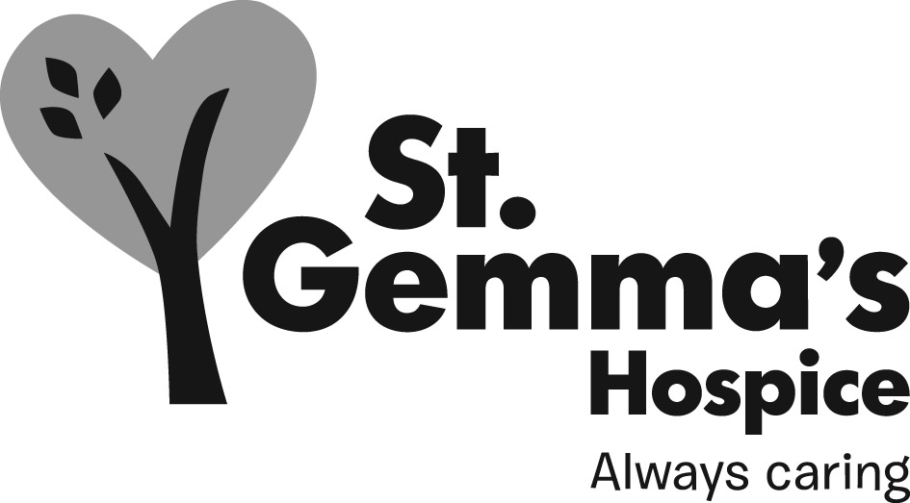
Reports to: | Facilities Supervisors / Senior Chef
Accountable to: | Facilities Services Manager

Main Purpose of Post

To support the Senior Chef, Facilities Supervisors, Health Care Assistants and Chefs in providing a seamless food service to patients, all visitors, Academic Unit of Palliative Care (AUPC) clients, volunteers and staff.

To assist your colleagues in the process of providing the Hospice with a quality laundry service and a clean, tidy and hygienic environment for the patients, staff and visitors.

To perform duties to maintain the highest level of customer service in all areas of the Hospice.

To perform basic food preparation.

Housekeeping Key Responsibilities

To ensure that the services are on-going to agreed standards, by following the Facilities Operational Policies.

To use all equipment following the set procedures and practices documented in the Operations Manual.

To record duties carried out correctly on relevant check sheets daily.

To use cleaning products following safety instructions, with particular reference to COSHH.

To monitor stock levels within the department and request replacements following the agreed channels. Stock rotation principals should be followed at all times.

To show regard for the environment within the Hospice.

To adhere to good practices regarding Health and Safety issues within the workplace.

To re-prioritise workload if required to deal with an emergency.

To ensure the all areas of the hospice are clean and free from hazards.

Food Service Key Responsibilities

Depending on the role you are covering may include but are not limited to the following:

To take food orders, set up, prepare and serve refreshments to all patients, staff, visitors and AUPC clients, in accordance with set procedures and practices.

To ensure food is served at the correct temperatures and that temperatures are recorded accurately in accordance with the Hospice procedures.

To ensure the clearing away of food and refreshments are timed in accordance with the needs of patients, staff, visitors and AUPC clients.

To carry out basic food preparation as and when required.

To wash all crockery, cutlery and glassware ensuring a high level of cleanliness is maintained.

To ensure correct storage of kitchen equipment and utensils are carried out.

To clean the catering areas following the Hospice procedures and record on the check sheets that the task has been completed.

To use kitchen equipment following set procedures and practices in accordance with the manufacturers operating instructions, whilst promoting a safe working environment.

Ensure that the service provision of food and beverages is on-going and adheres to the Food Services Operational Policy.

To show awareness of cleaning products and procedures within the catering areas, maintain the cleanliness of the catering areas and work within the parameters of the cleaning routine or as directed by the Food Service Supervisor or Senior Chef.

To be fully aware of COSHH instructions for cleaning products, not using any products which you are not conversant with. Wear protective clothing to ensure own personal safety and those of other staff.

To maintain and replenish food and cleaning stock levels in the Bistro, AUPC and other catering areas including topping up and cleaning the coffee machines.

To operate and cash up the till, following the Finance - Bistro Cashing Up Policy, when on duty in the Bistro.

Personal Responsibilities

To be willing to work in other Facilities sections departments and attend staff meetings, and work to agreed action points as required.

To co-operate and liaise with other colleagues to provide a clean, hygienic environment in the Hospice.

To support and encourage a harmonious working relationship within the department and the Hospice environment.

To work closely with the other colleagues within the hospice to provide a seamless customer and housekeeping service.

To maintain a dress and personal hygiene standard including the wearing of the uniform provided by the Hospice.

To participate in courses and training to improve/learn new skills.

To assist in the welcoming of new Facilities staff and to demonstrate the use of equipment and how to perform tasks.

To incorporate new procedures and skills as required and participate in the Individual Performance Reviews (IPR).

General duties and responsibilities

All St Gemma’s employees are required to abide by the Health and Safety at Work Act, attend annual mandatory training sessions and ensure that they comply with Hospice policies and procedures at all times.

Employees must demonstrate commitment to their own personal development and are required to make a positive contribution to fundraising and raising the profile of the Hospice locally and nationally.

Strict confidentiality applying to all aspects of Hospice business must be observed at all times.

This Role Profile is not exhaustive. It will be subject to periodic review and may be amended following discussion between the post holder and employer.

