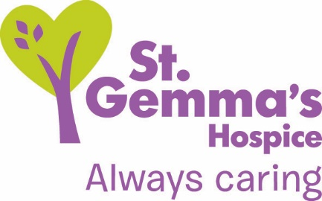

Registered Charity No. 1015941

Title of Role: Shop Volunteer
Department: Retail
Supervisor: Shop Manager and Deputy Shop Manager
Location: 24 charity shops across Leeds – please look at our shops list.
Time commitment: One or two mornings or afternoons per week. However, two hours once a
week is also valuable. Shops are open Monday to Saturday, 9am to 5pm
DBS check needed? No

St Gemma’s Hospice provides the best possible care and quality of life for local people with cancer and other life threatening illnesses. It’s a friendly, warm and safe place at the heart of the local community with a large range of expert services to support patients, their families and friends. Whether our volunteers help in our shops or at the Hospice, they all contribute to helping St Gemma’s care for local people at the most difficult time in their lives.

Role Summary
Join the team and help to make St Gemma’s shops a huge success on the high street. Our shops raise much needed funds to support local people facing cancer and other life limiting illnesses.

There are a number of different roles in each of our charity shops. You may prefer to concentrate on one aspect of the shop or you might rather have some variety during your shift. The Shop Manager will discuss this with you and provide training and advice.

- What’s involved?
- Serving customers. This includes:-
- assisting customers with their choice of goods
- ringing sales through on the till
- dealing with queries about the shop and Hospice
- dealing with Gift Aid donations

- General shop floor work. This includes:-
- keeping the shop clean and tidy, dusting shelves, vacuuming
- putting out stock
- replenishing and merchandising stock
- tidying the rails

- Back room work. This includes:-
- sorting donations brought in by the public and by our van drivers
- hanging, sizing and pricing clothes
- steaming clothes ready for the shop floor
- pricing books, bric-a-brac and accessories

- What we will offer you
- The chance to develop customer service skills and stock control skills
- The opportunity to learn how to use a till
- The chance to work with a friendly team
- The opportunity to make a difference to the lives of local people
- A named line manager who will support you in your work
- An invitation to a Hospice wide induction
- Invitations to Volunteer thank you events

- What we’d like from you
- To be polite, friendly and have good people skills
- Ability to work well within a small team
- Willingness and flexibility to undertake a range of practical duties and activities
- An understanding that you need to leave a message at the shop if unwell or unable to attend
- To be familiar with fire, health safety and reporting of incidents procedure – this will be part of your training

- How to apply
Simply phone or drop into your local branch and arrange to meet up with the Shop Manager for an informal chat about the role. If all goes well, we’ll ask you to complete an application form and the Shop Manager will take up your reference. The Shop Manager will contact you with a start date and will introduce you to your fellow volunteers and arrange training.

Alternatively, you can submit an application form via our online recruitment platform at recruitment.st-gemma.co.uk/application-form
To discuss this opportunity in greater detail please call Christine Driver on 0113 255 7552 or email christined@st-gemma.co.uk.

Values and Behaviours

St Gemma’s Hospice has a set of values and behaviours and all volunteers are expected to behave in line with the values detailed below.

- Caring - Treating each person with kindness, empathy, compassion and respect.
- Aspiring - Continually learning and developing; striving for excellence in everything we do.
- Professional - Delivering high standards through team work, a skilled workforce and good governance.

Thank you

St Gemma’s Hospice could not survive without the help and support provided by volunteers who give their time and energy so selflessly. Your contribution really will make a difference to the lives of local people.

February 2016

