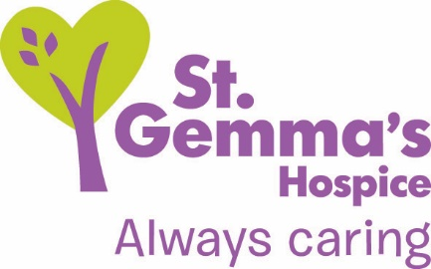

Registered Charity No. 1015941

Title of Role: Complementary Therapist Volunteer
Department: Therapy Team
Supervisor: Complementary Therapy Lead
Location: St Gemma’s Hospice, 329 Harrogate Road, Leeds, LS17 6QD
Time commitment: Roughly 3- 5 hours once a week, either a morning or afternoon, Monday to
Friday
Deadline: 9am, Monday 22nd October
DBS check needed? Yes: This post is exempt from the Rehabilitation of Offenders Act 1974 and therefore a Disclosure and Barring Services (DBS) check will be carried out on preferred candidates. Please see statement on recruitment of ex-offenders by visiting www.st-gemma.co.uk/volunteering.

St Gemma’s Hospice provides the best possible care and quality of life for local people with cancer and other life threatening illnesses. It’s a friendly, warm and safe place at the heart of the local community with a large range of expert services to support patients, their families and friends. Whether our volunteers help in our shops or at the Hospice, they all contribute to helping St Gemma’s care for local people at the most difficult time in their lives.

Role Summary
To provide a service as a member of the complementary therapies team and deliver complementary therapy treatments to patients and carers. There is also the possibility that complementary therapy volunteers can offer their services to the public in fundraising opportunities for the Hospice.

- What’s involved?
- Use your Complementary Therapy skills to provide a holistic approach to patients and their carers, in collaboration with the other members of the multidisciplinary team, in order to ensure the provision of the highest quality of care.
- Provide care over a number of settings across the Hospice including Day Services and the Wards.
- Provide feedback on the patient’s well-being to the relevant Nurse and the Complementary Therapy Lead, and document in the patient’s notes.

- What we will offer you
- Participate in 6-8 weekly clinical supervision with the Complementary Therapy Lead.
- The opportunity to work with a friendly team.
- A named supervisor who will support you in your work.
- An invitation to an induction and training session.
- Invitations to Volunteer thank you events.

- What we’d like from you
- Be qualified, insured and registered with a professional body to practice a complementary therapy. This could be in therapeutic massage, aromatherapy, reflexology or reiki.
- Be able to demonstrate a sound understanding of complementary therapies, in particular the therapy for which you are qualified to practice.
- Have an understanding of the patient’s diagnosis, treatment, care and current condition.
- Be aware of contraindications or precautions in relation to the therapy you practice and to be able to adapt a treatment accordingly.
- Be committed to developing skills and knowledge related to the care of patients with active, progressive and advanced disease.
- Be committed to your own continuing professional development.
- Follow the Guidelines for Practice for Volunteer Complementary Therapists.
- Follow the Complementary Therapies policy and other Hospice policies relating to patient care and confidentiality.

- How to apply
Please submit an application form online by visiting www.st-gemma.co.uk/volunteering.

To discuss this opportunity in greater detail please call Kathryn Booth on 0113 2185500 ext 2069, or email kathrynbo@st-gemma.co.uk

Thank you

St Gemma’s Hospice could not survive without the help and support provided by volunteers who give their time and energy so selflessly. Your contribution really will make a difference to the lives of local people.

October 2018

