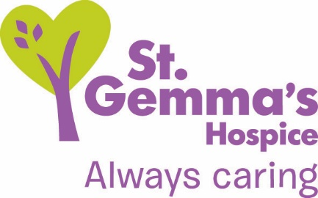

Registered Charity No. 1015941

Title of Role: Volunteer Van Driver
Department: Retail
Supervisor: Retail Support Manager
Location: 329 Harrogate Road, Leeds, LS17 6QD
Time commitment: Monday to Saturday, flexible day time hours.

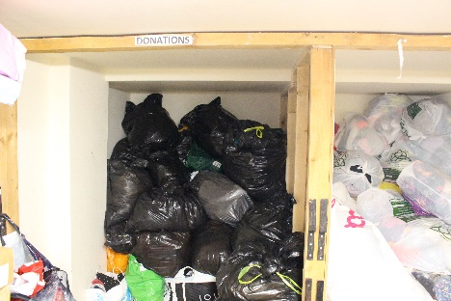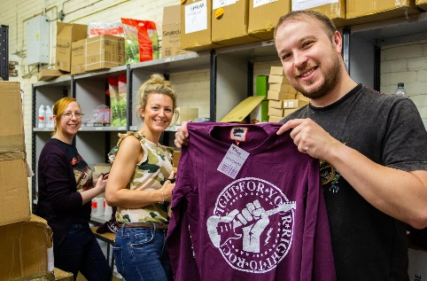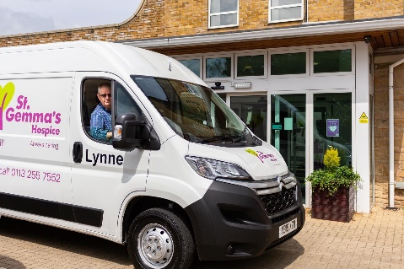

About St Gemma’s Hospice

St Gemma’s Hospice provides the best possible care and quality of life for local people with cancer and other life threatening illnesses. It’s a friendly, warm and safe place at the heart of the local community, with a large range of expert services to support patients, their families and friends. Whether our volunteers help in our shops or at the Hospice, they all contribute to helping St Gemma’s care for local people at the most difficult time in their lives.

About our Retail Department

St Gemma’s Hospice currently has 23 shops as well as the busy Retail Hub, which includes the warehouse and e-commerce department. Stock is sorted and distributed from our warehouse, as well as being donated across our shops. We currently collect furniture and larger donations from the public which is sold at our dedicated furniture shops. Our Volunteer Van Drivers are instrumental to the process as we can get more stock to our shops and generate stock through customer collections.

Role description
Supported by a Volunteer Van Driver Assistant you will support the retail team with the distribution of donated stock. Tasks include:

- Driving the St Gemma’s Hospice van across all areas of Leeds
- Collect and distribute bags to and from the warehouse and St Gemma’s 23 shops
- Handling of heavy furniture items from the warehouse/customer houses to St Gemma’s Furniture shop
- Loading items from the Hospice clothing and book banks on to the van for distribution to the shops
- Visiting customer homes to collect donations
- Adhere to all Health & Safety & Safeguarding guidelines

Skills & Qualifications
Essential
- Full driving licence
- Excellent customer service skills
- Able to work as part of a team
- A good level of physical fitness
Desirable
- Experience of driving a van
- Good knowledge of Leeds
- Knowledge of furniture safety guidelines
Benefits of volunteering at St Gemma’s Hospice:

- On-going training provided by our retail & warehouse staff
- All volunteers attend our Hospice induction program (currently via zoom)
- Be part of a fantastic team of volunteers, at the forefront of charity retail
- Have the opportunity to use your skills to complement & influence the work of the Hospice to make a difference to people during a difficult time.
- Support from a named supervisor
- Volunteer e-news keeping you up to date with hospice information
- Regular volunteer events to share ideas and socialise with volunteers and staff.
Values and Behaviours

St Gemma’s Hospice has a set of values and behaviours and all volunteers are expected to behave in line with the values detailed below.

- Caring - Treating each person with kindness, empathy, compassion and respect.
- Aspiring - Continually learning and developing; striving for excellence in everything we do.
- Professional - Delivering high standards through team work, a skilled workforce and good governance.

How to apply

Please submit an application form online by visiting www.st-gemma.co.uk/volunteering.

To discuss this opportunity in greater detail please call Sarah Baldock, Retail Support Manager on 07748 845354, or email sarah.baldock@st-gemma.co.uk

Thank you

St Gemma’s Hospice could not survive without the help and support provided by volunteers who give their time and energy so selflessly. Your contribution really will make a difference to the lives of local people.

