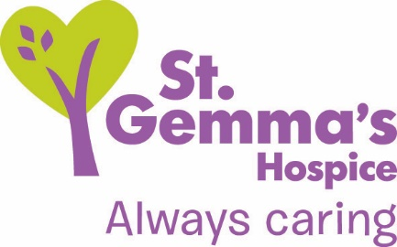

Registered Charity No. 1015941

Title of Role: Volunteer Warehouse Assistant
Department: Retail Hub
Supervisor: Retail Support Manager
Location: 54 Waterloo Lane, Bramley, LS13 2EL
Time commitment: Monday to Saturday, flexible day time hours.

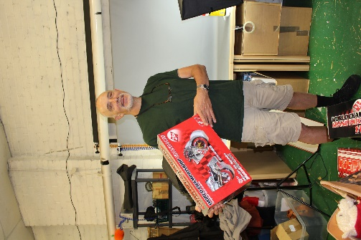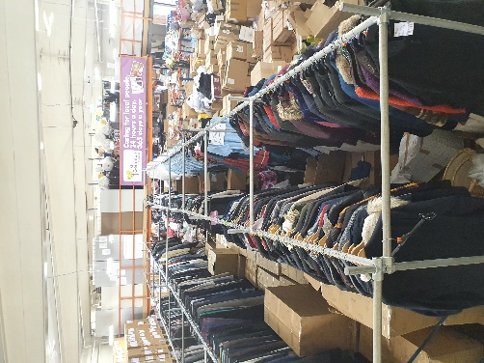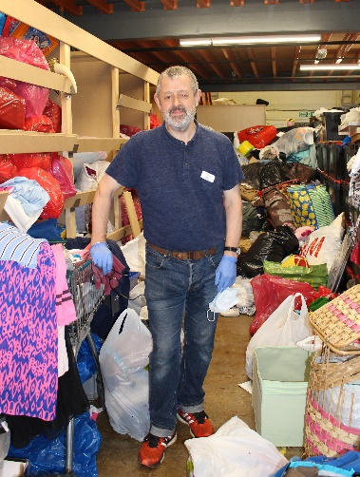

About St Gemma’s Hospice

St Gemma’s Hospice provides the best possible care and quality of life for local people with cancer and other life threatening illnesses. It’s a friendly, warm and safe place at the heart of the local community, with a large range of expert services to support patients, their families and friends. Whether our volunteers help in our shops or at the Hospice, they all contribute to helping St Gemma’s care for local people at the most difficult time in their lives.

About our Retail Department

St Gemma’s Hospice currently has 23 shops as well as the busy Retail Hub, which includes the warehouse and e-commerce department. Stock is sorted and distributed from our warehouse, as well as being donated across our shops. We currently collect furniture and larger donations from the public which is sold at our dedicated furniture shops. Our Volunteer Warehouse Assistants are instrumental to the process as the more stock we can sort, the more we have to sell and raise money to support patients and their families.

Role description
Working with our amazing team of warehouse volunteers you will be involved with tasks including;

Greeting donors
- Accepting donations from the public
- Signing donors up to Gift Aid

Sorting donations
- Sorting donations brought in by the public and by our van drivers
- Hanging and sizing clothes
- Sorting books, bric-a-brac and accessories
- Identifying items for sale on our E-bay, Depop & Vinted sites
- Recycling items through the correct channels

General housekeeping
- Keeping the warehouse clean and tidy
- Adhering to health and safety regulations

Skills & Qualifications
Essential
- Excellent customer service skills
- Able to work as part of a team
- A good level of physical fitness
Desirable
- Expertise in any areas of goods we sell e.g. vintage clothing, books, ornaments/vases!

Benefits of volunteering at St Gemma’s Hospice:
- On-going training provided by our retail & warehouse staff
- All volunteers attend our Hospice induction program (currently via zoom)
- Be part of a fantastic team of volunteers, at the forefront of charity retail
- Have the opportunity to use your skills to complement & influence the work of the Hospice to make a difference to people during a difficult time.
- Support from a named supervisor
- Volunteer e-news keeping you up to date with hospice information
- Regular volunteer events to share ideas and socialise with volunteers and staff.
Values and Behaviours

St Gemma’s Hospice has a set of values and behaviours and all volunteers are expected to behave in line with the values detailed below.

- Caring - Treating each person with kindness, empathy, compassion and respect.
- Aspiring - Continually learning and developing; striving for excellence in everything we do.
- Professional - Delivering high standards through team work, a skilled workforce and good governance.

How to apply

Please submit an application form online by visiting www.st-gemma.co.uk/volunteering.

To discuss this opportunity in greater detail please call Jason Maciag, Warehouse Manager on 0113 255 7552 or email Jason.Maciag@st-gemma.co.uk

Thank you
St Gemma’s Hospice could not survive without the help and support provided by volunteers who give their time and energy so selflessly. Your contribution really will make a difference to the lives of local people.

