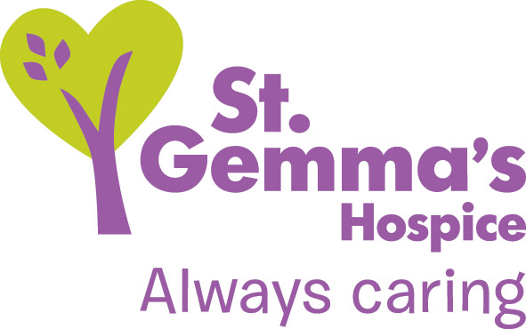
Store Collector Role Profile

Day to Day Responsibility: Maria White and other members of the Fundraising Department.
Overall Accountability: Maria White, Community Fundraiser
Overview of the Role: The Community Fundraising Department are looking for individuals to join our dedicated team of store collectors to help us raise vital funds for the Hospice
Time Commitment: This role is extremely flexible. As a collection volunteer you are free to decide how little or how often you would like to collect. You could give as little as an hour a month of your time.
We book collection dates at various supermarkets which can be on weekdays or weekends and collectors usually collect for 1-4 hours a time

St Gemma’s Hospice
St Gemma’s Hospice provides care to people in Leeds who are living with a life limiting illness. We provide expert, specialist medical care as well as emotional and practical support, ensuring all patients are treated as individuals. Each year we care for around 2500 local people, including providing bereavement support to friends and families and our growing Young Peoples’ service.
The Hospice has a fantastic and dedicated in-patient unit and our Community Nurses also care for people in their own homes 365 days a year. Patients can also access support through our Day Hospice, ensuring that patient choice remains central to the care we provide.

Why we need you
All of the care we provide is free to access, but it is not free to provide. It costs £25,000 each and every day to run all of our services, the majority of which has to be raised through gifts left in wills, our chain of charity shops, fundraising events and initiatives.
Each month we write out to local stores and supermarkets in Leeds to ask if we are able to collect for the Hospice. Collection dates are increasingly hard to come by and we need enough store collectors to make the most of every collecting opportunity. This opportunity is extremely flexible and collectors can collect for as little as an hour at a time.

General Duties and Responsibilities
- Collecting donations from the public at stores and supermarkets across Leeds
- Speaking to the public and raising awareness of the Hospice’s work
- Collecting and returning the collection boxes to the Hospice in Moortown.

Skills Required

- Good communication skills when meeting with the general public and working with oth collectors.

- Confidence when speaking to the public and talking about the Hospice.

- Passion and enthusiasm for St Gemma’s Hospice.

- A willingness to learn about the Hospice and keep up to date with changes.

Please note: You will not be required to count the money you have collected. After a collection, the boxes are returned to the Hospice and counted by our finance department. We will then write to you and let you know how much you raised.

Benefits of the role

- The full support of the fundraising team

- Meeting with and working with new people all working towards the same goal

- Your own collection volunteer fundraising pack with St Gemma’s sash and badge

- Satisfaction of knowing that you have helped us to support people in Leeds and their families at the most difficult time of their life

- Training and support from the Fundraising team and Volunteers Coordinator at the Hospice.

- An invitation to all of our Volunteer Thank you events where you will be given the latest news about the Hospice.

- Annual meetings with the Fundraiser and all of the other store collectors to thank you for your time and discuss any new ideas or concerns.

Guidelines
- All applicants need to be aged 16 and over.
- Collectors are asked to return boxes unopened back to the Hospice after a collection for the Hospice finance department to count.
- Collectors must thank every member of the public for their donation no matter how small.
- Volunteers are asked to wear their name badge at all times and should make themselves familiar with the Hospice volunteer policies.
- Strict confidentiality applies to all aspects of Hospice business and must be observed at all times.
- We will do our best to develop your volunteering role with us should you wish to, and training opportunities will be provided where possible.
- Anybody wishing to become a store collector will complete a volunteer’s application form, submit references and meet with the Community Fundraiser. A Volunteers Agreement will then be read and completed before appointment.
- We are sometimes able to reimburse travel expenses, depending on the circumstances.

If you have any other questions please contact:
Maria White
St Gemma’s Hospice
329 Harrogate Road
Leeds
LS17 6QD
0113 218 5196
maria.white@st-gemma.co.uk
Date: August 2019

